COLORES NATURA APP

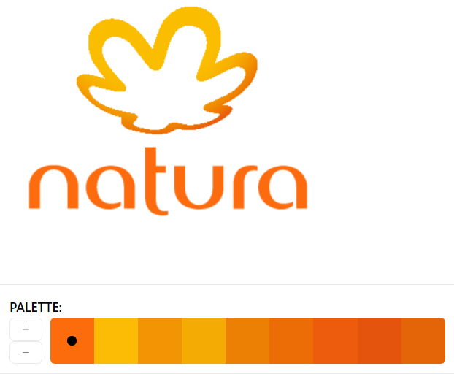

fc6c0c fcbb04 f39404 f4ab04 ec8004 ec6d05 ec5c0c e4540c e46408